Name : Sakthi Manoj R Reg No : 192324236
PROGRAM 12
Perform Data Reshaping on the Air Quality Dataset and Calculate Monthly Averages
Aim:
To explore the airquality dataset and calculate monthly averages for Ozone, Solar Radiation, Wind, and Temperature.
Procedure:
Step 1: Open RStudio or the R console on your computer.
Step 2: Load the built-in airquality dataset using data("airquality").
Step 3: Use the aggregate() function with cbind() to group Ozone, Solar.R, Wind, and Temp by Month.
Step 4: Set na.rm = TRUE so missing values are ignored while calculating averages.
Step 5: Store the monthly average values in a new variable.
Step 6: Print a message indicating that the monthly averages are being displayed.
Step 7: Display the result to view the average values for each month.
Output :
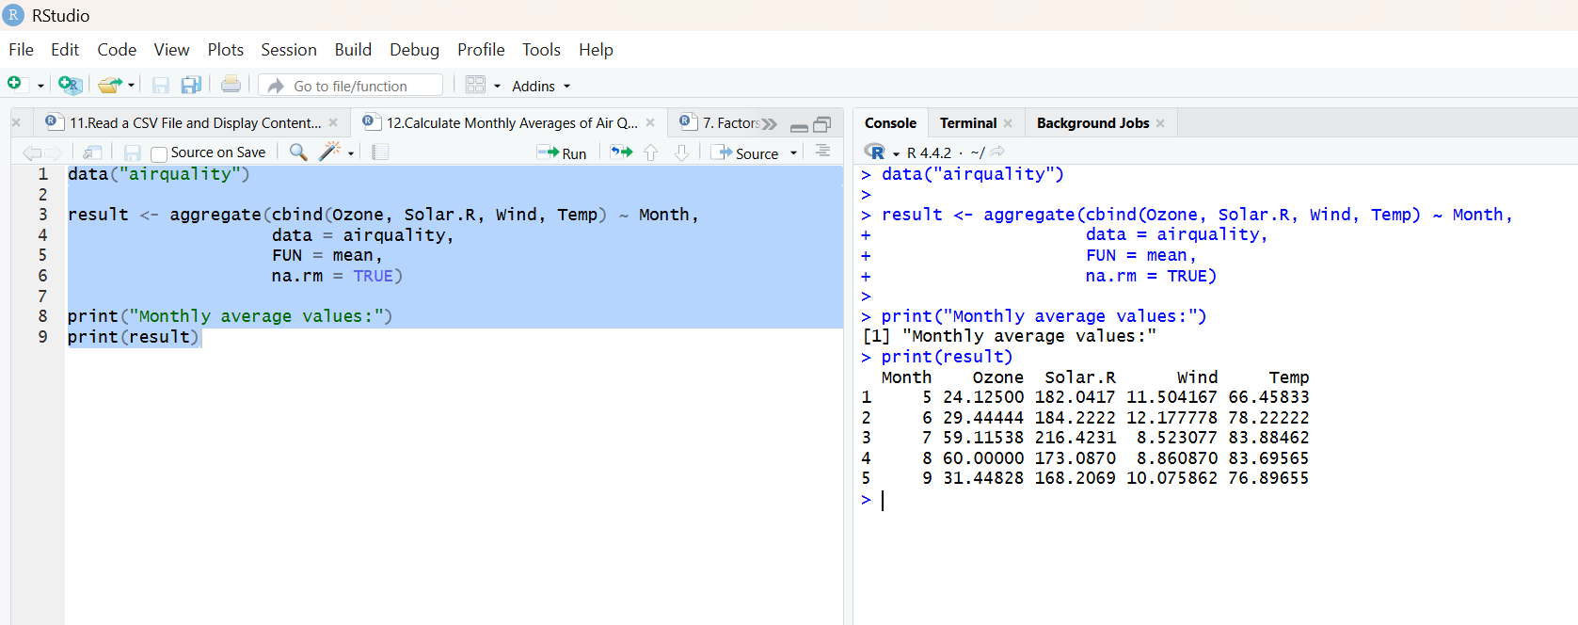
Result:
Hence the output is verified successfully.

